- Set up each student’s work station with a piece of newsprint, a canvas mat (only if using white clay), guides (optional), and a rolling pin. Write each student’s name on the newsprint. |  | - Begin by rolling out a small amount of clay; try to make the shape roughly circular. Guides can be used but aren’t necessary. Don’t roll the clay out too thin!
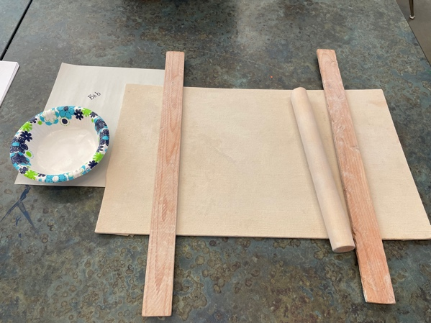  Note: You may want to pass out the rolling pins when you are ready to start the lesson…because they also make great percussion instruments! |  | 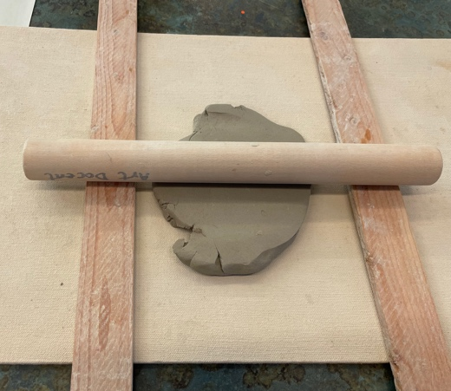
- Pop any air bubbles! |  | - Add all sorts of texture! Go wild!
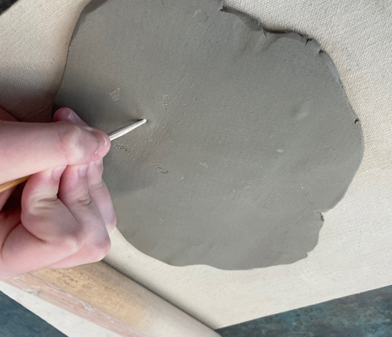 |  | 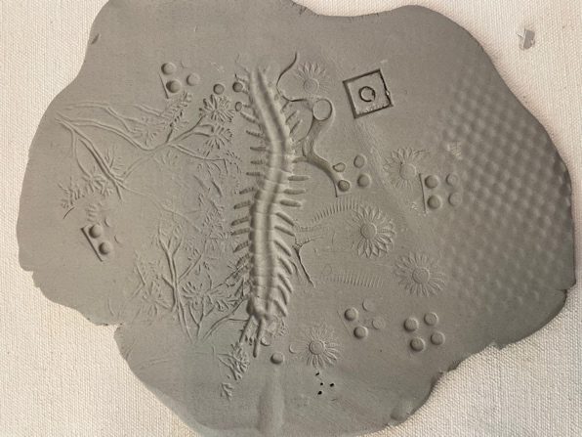
- Lay clay piece into a paper or plastic bowl, making sure to gently ease it into the curves. Trim edges if needed. It doesn’t need to fit the bowl exactly, but too much overhang has the potential to break before firing. Done!

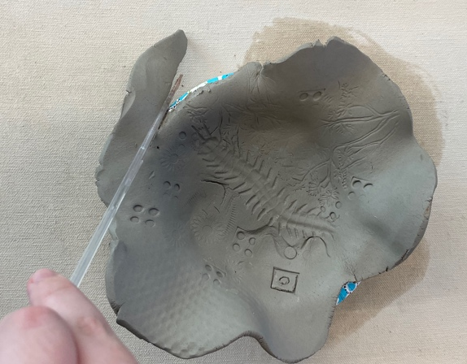 |  | 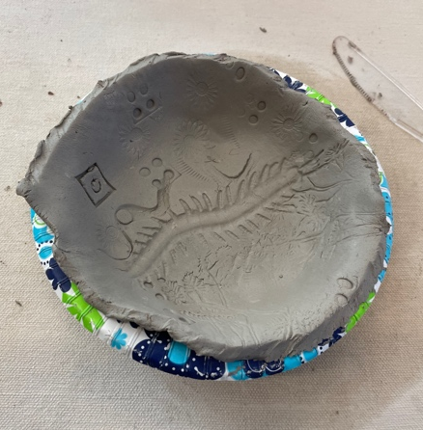
- Take the newsprint (with student’s name) and project in bowl and put them on a shelf in the kiln cage to dry for a few hours (up to a day). After they no longer distort when handling, you can remove the projects from the bowls. | - Make sure to scratch the student’s initials/name and year on the bottom with a wooden needle tool
 | 